Lancaster Seventh-Day Adventist Church
The Mission of the Lancaster Seventh-Day Adventist Church
is to be a Worshiping Community for Gospel Witness,
Christian Education, Caring Fellowship, and Loving Service
in an Environment of Grace.
Church Phone: 740.687.4860
Church Website: LovingHope.org
Good Neighbor Thrift Store: 687.6589
Lancaster S.D.A. School: 687.1741
+++++++++++++++++++++++++++++++++++
alschone@rocketmail.com
Team Leaders:

Lancaster Seventh-Day Adventist Church
A House of Prayer for All People

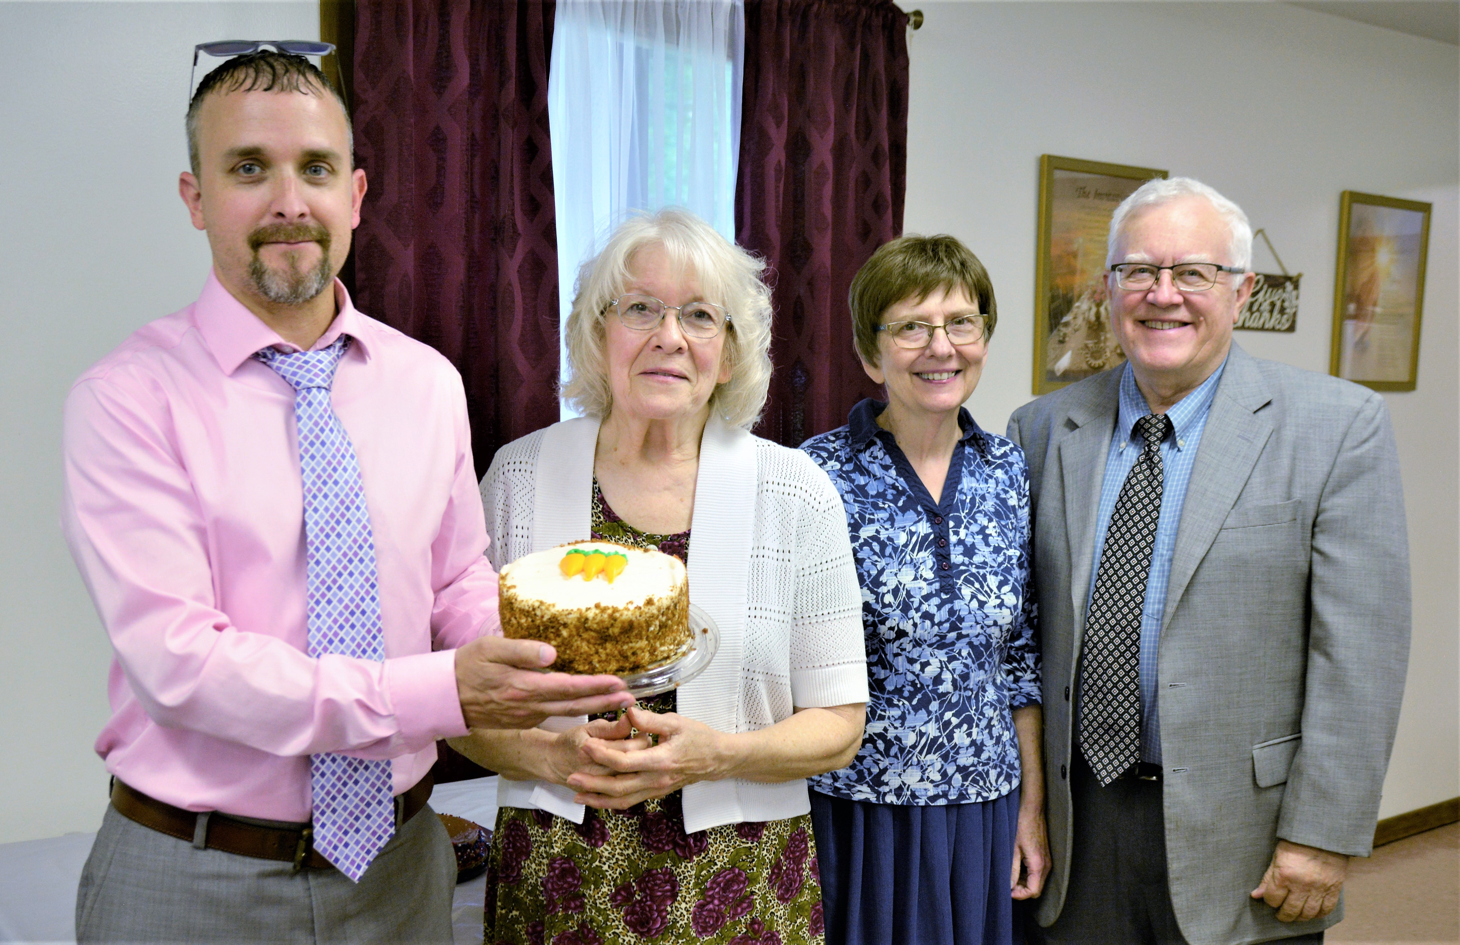
Birthdays: Jonathon, Donna Anniversary: Bonnie & Al
June Birthdays and Anniversary ~~ 2023

