Lancaster Seventh-Day Adventist Church
A House of Prayer for All People

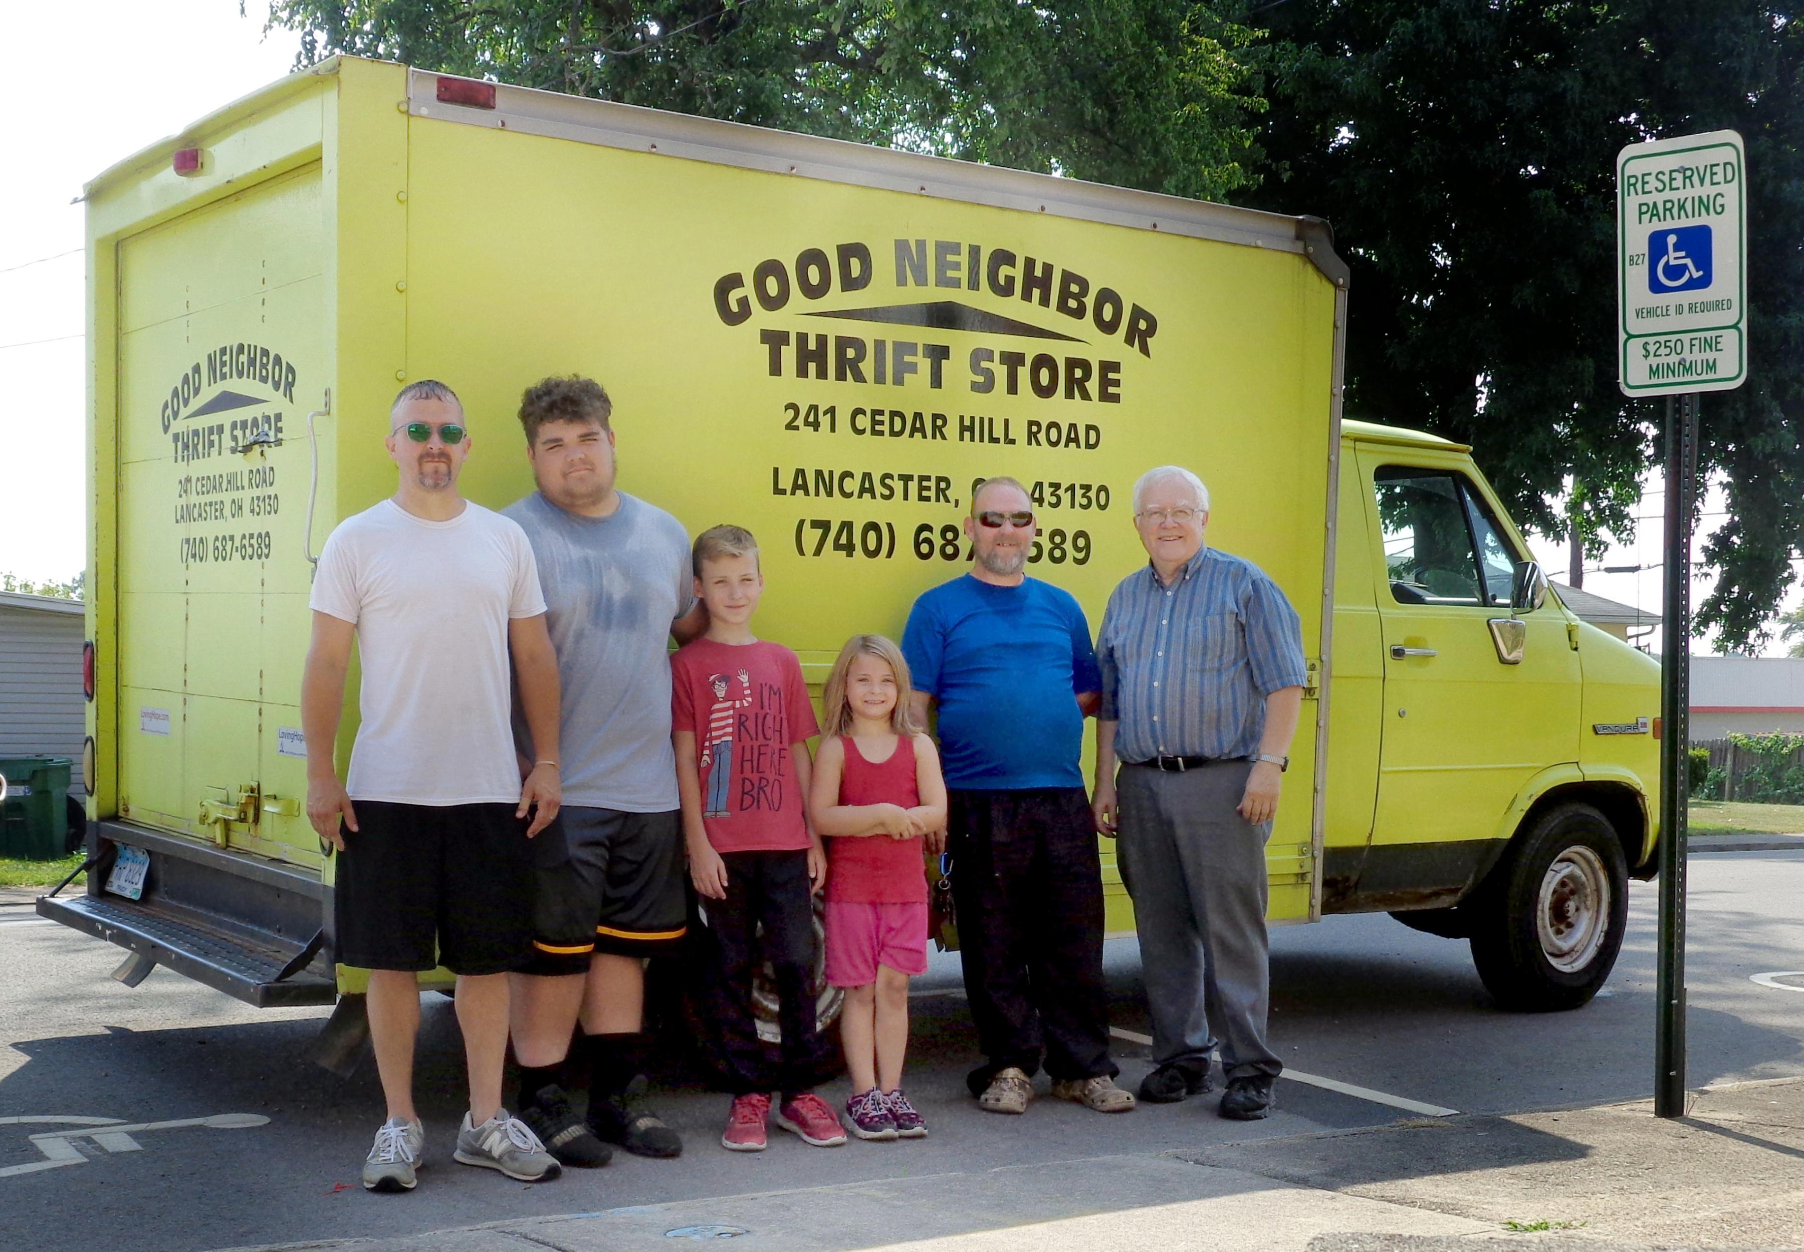

Jonathon, Aden, Levi, Sarah, John, Al
Good Neighbor Thrift Store Pick Up ~ August 8, 2021

