Lancaster Seventh-Day Adventist Church
A House of Prayer for All People

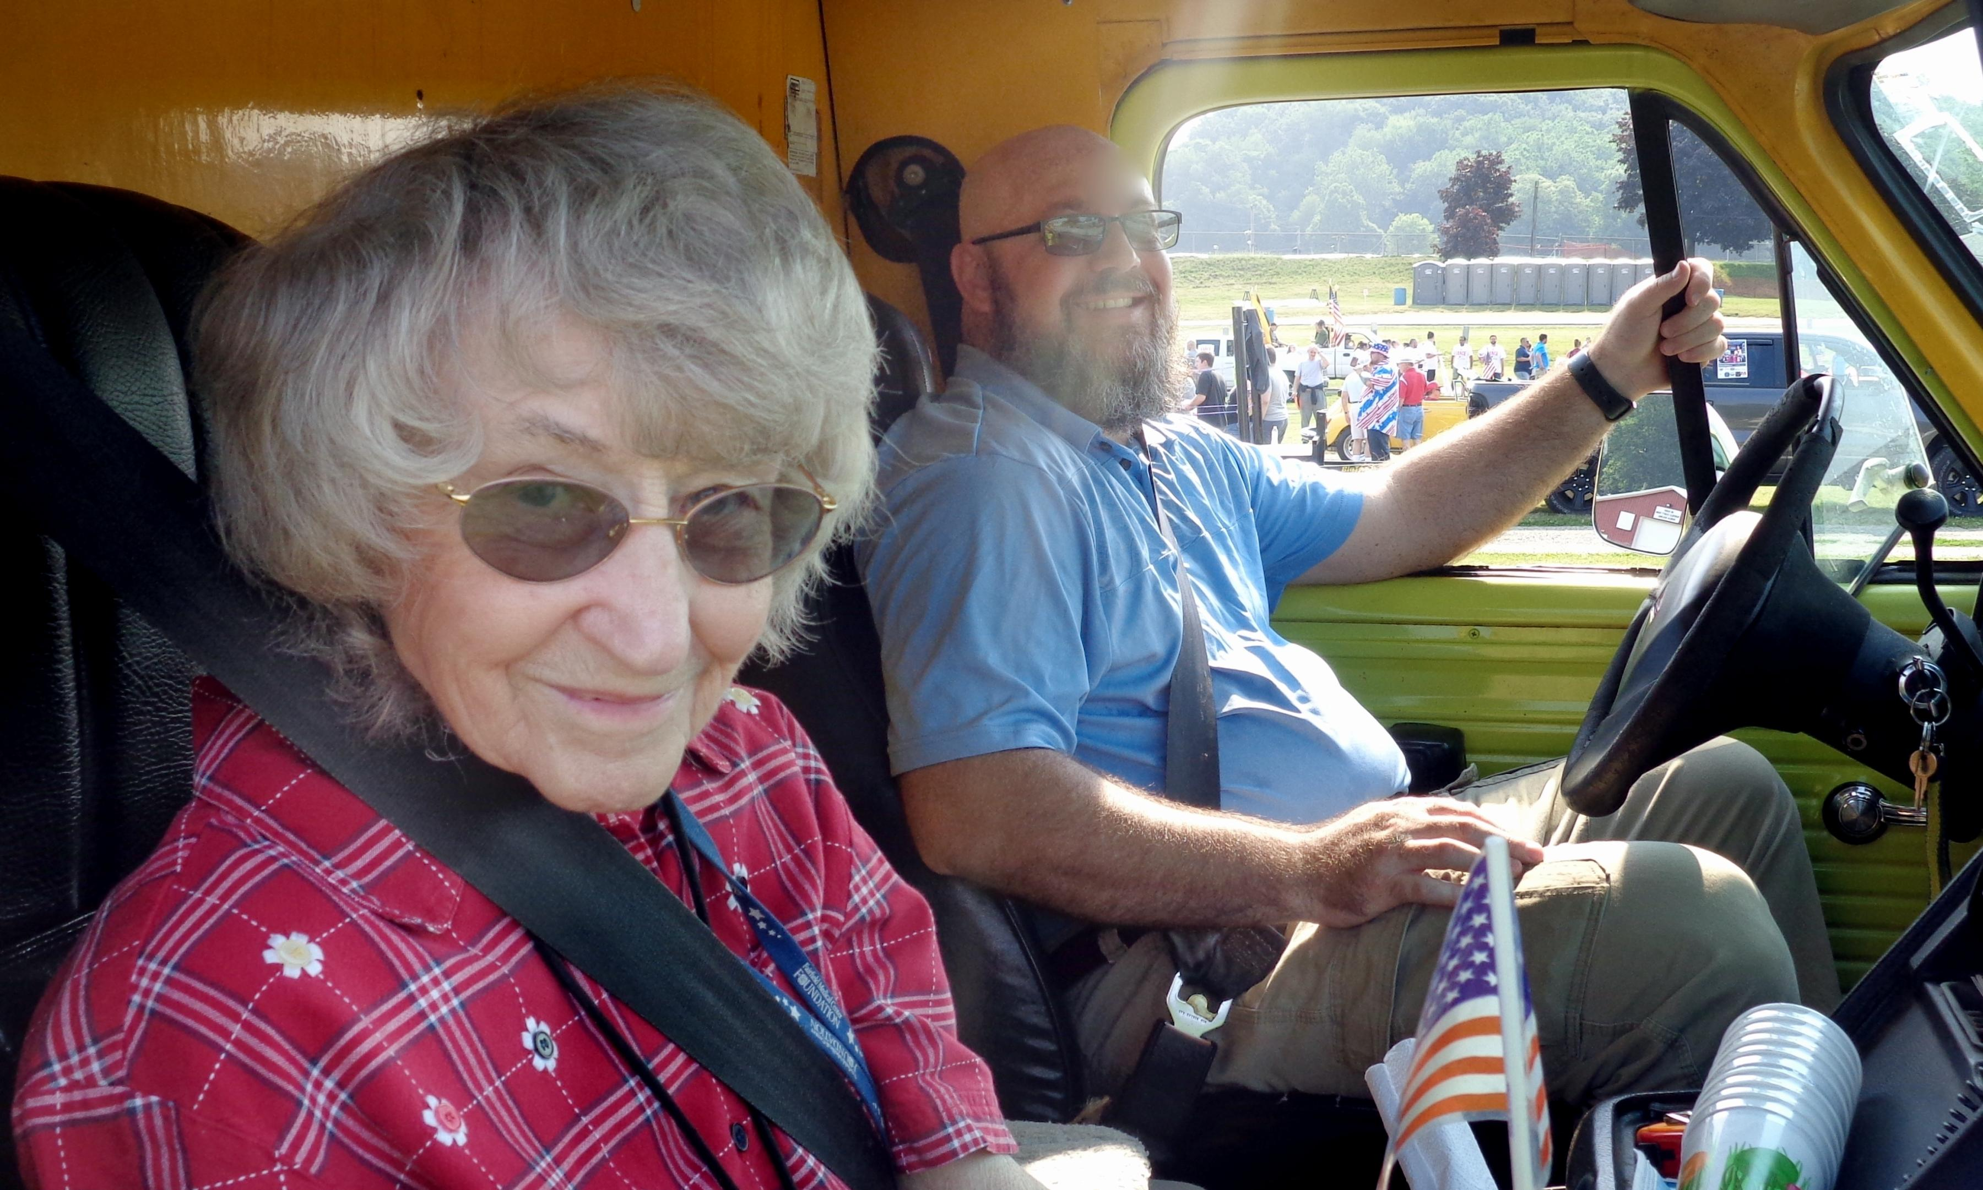

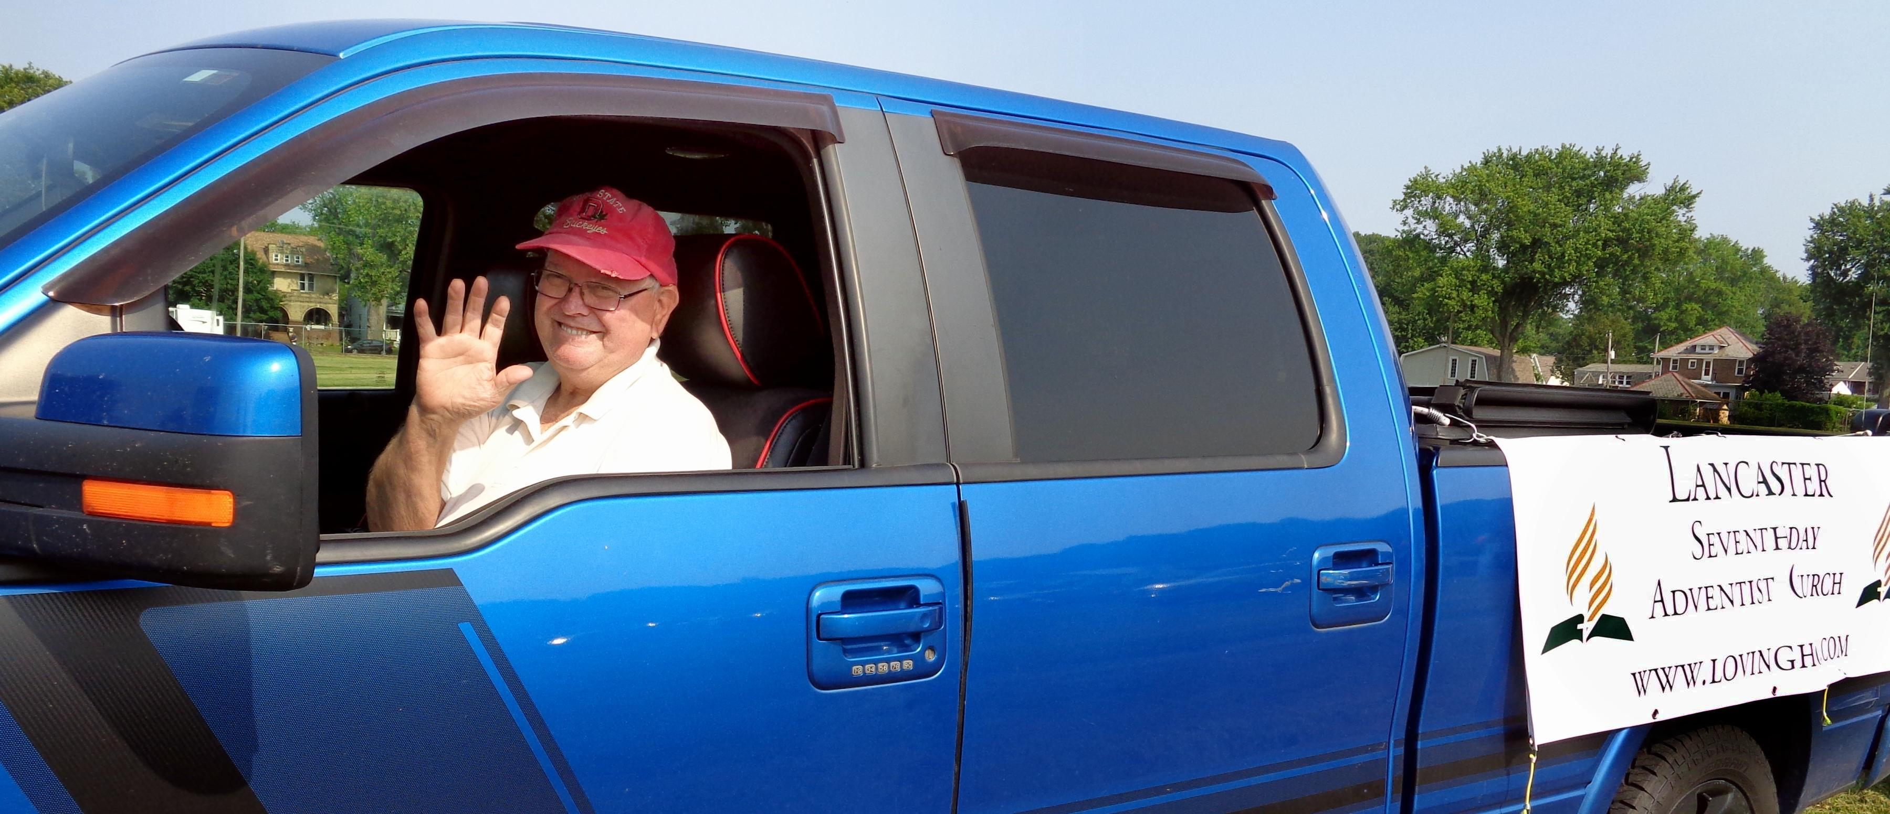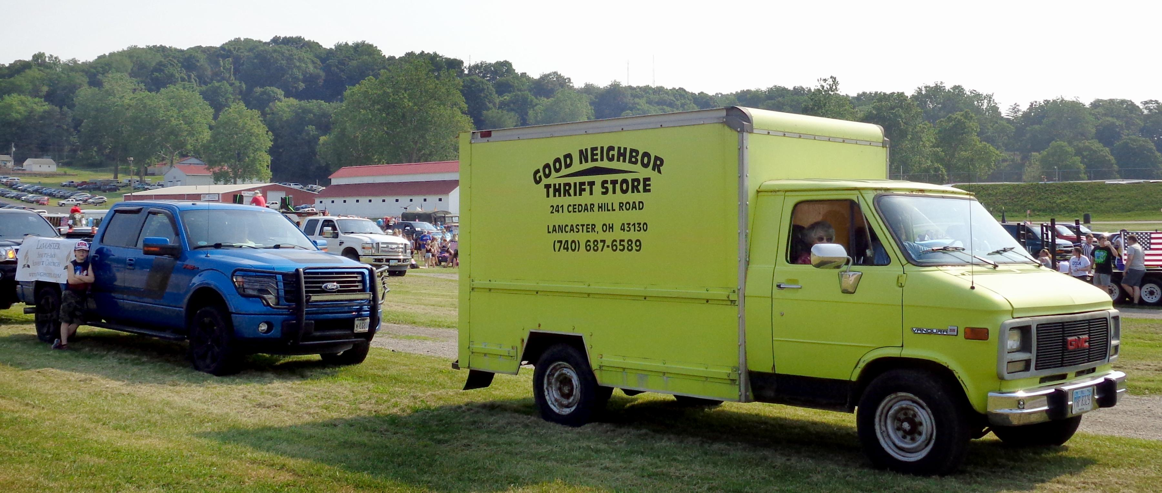
Darrell, Jesse, Al, Freda, Pastor Anthony
Lancaster Independence Day Parade ~ July 5, 2021

