Lancaster Seventh-Day Adventist Church
A House of Prayer for All People

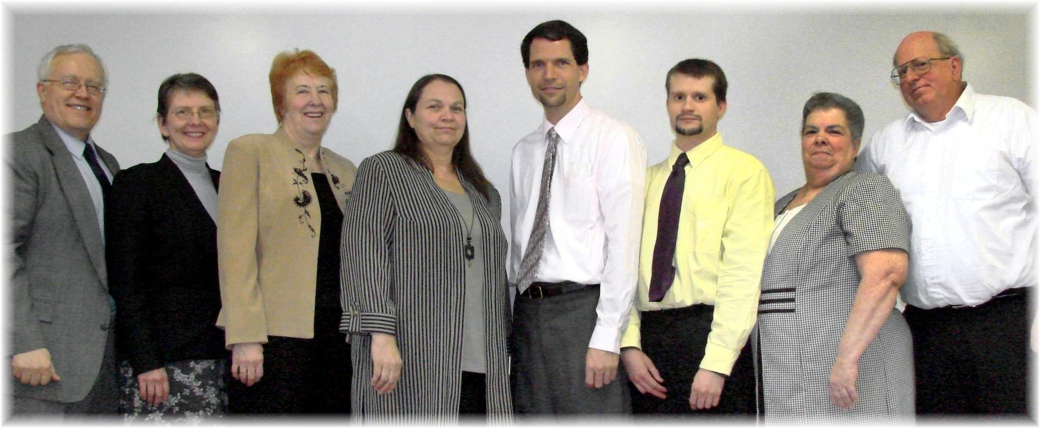
Al, Bonnie, Diane, Debby, Pastor Travis, Allen, Evelyn, Bill
Worship Team - 2010

