Lancaster Seventh-Day Adventist Church
A House of Prayer for All People

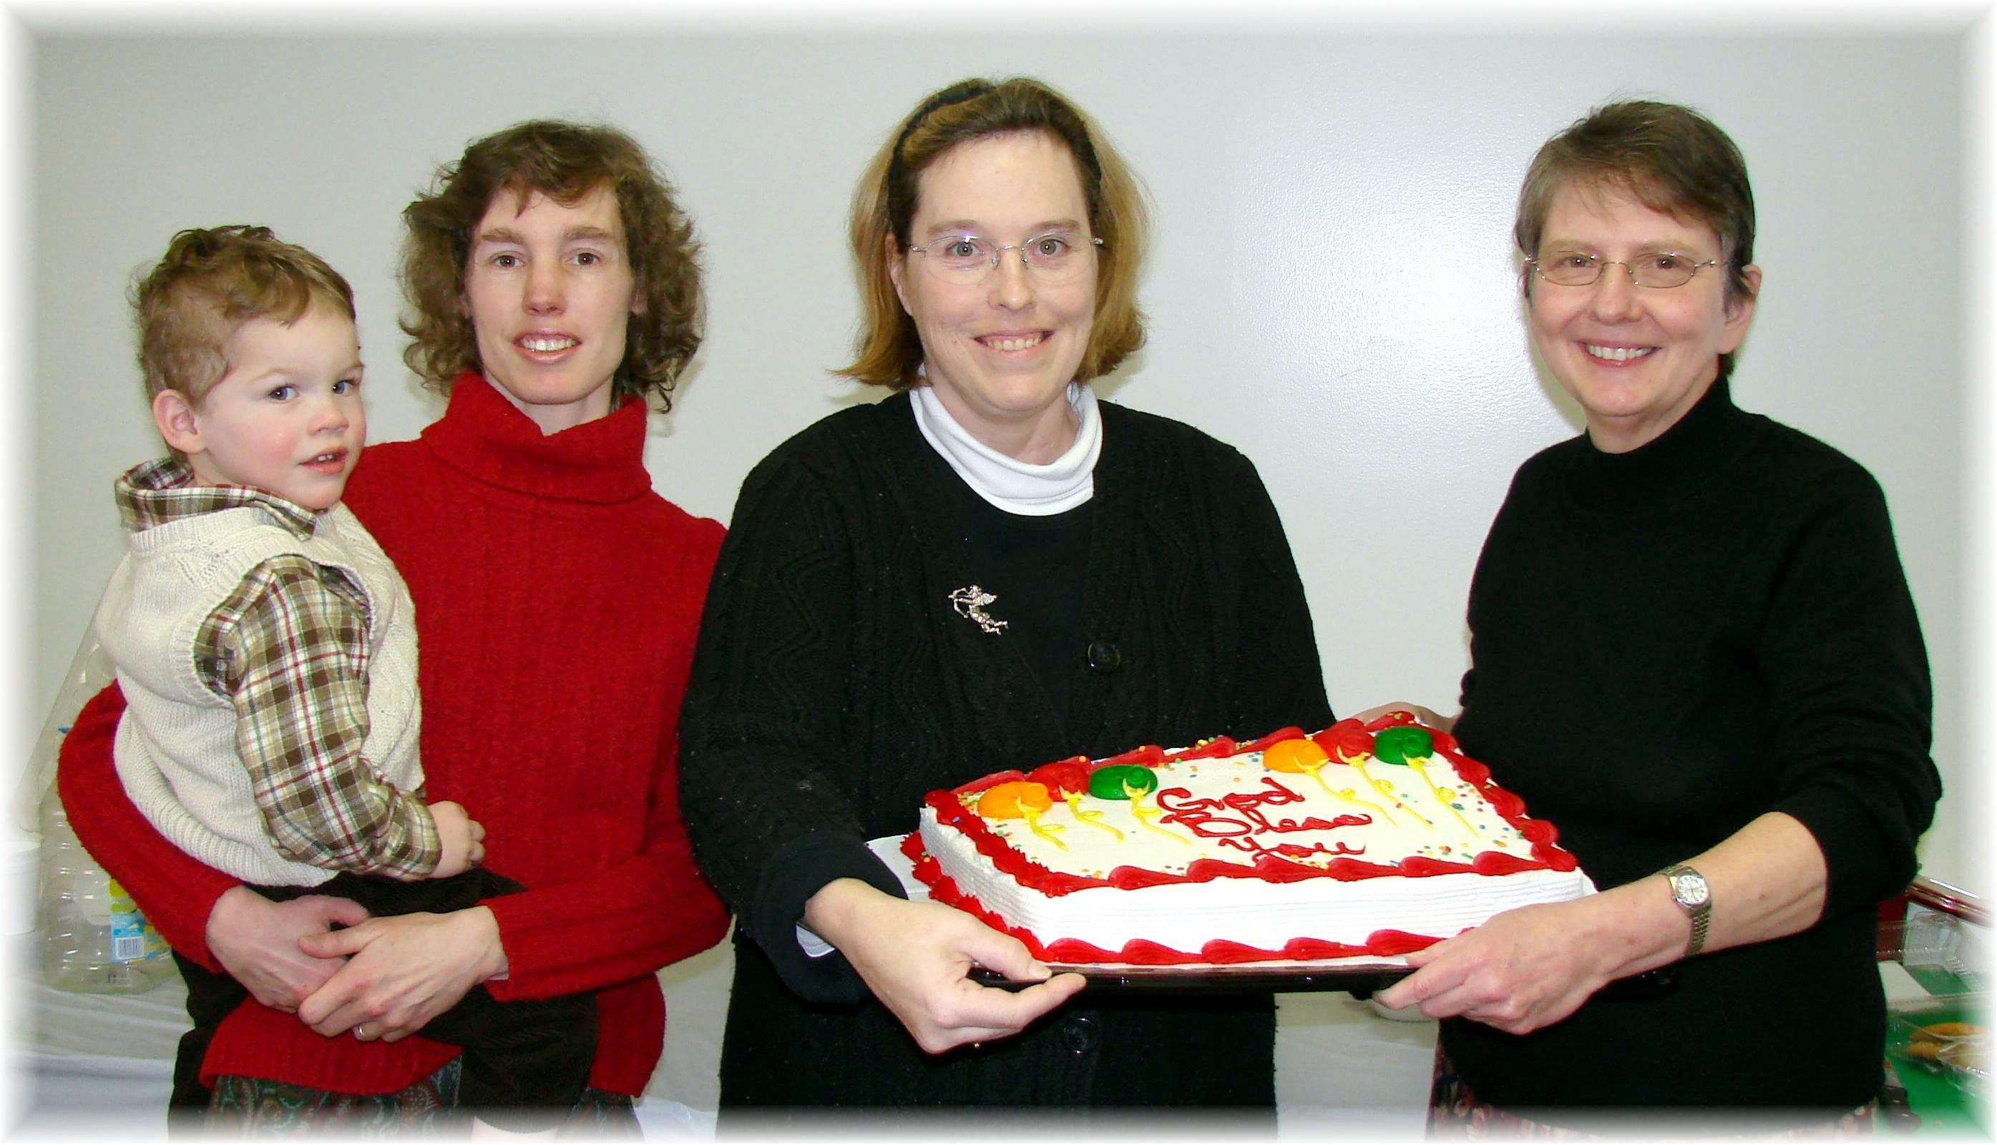
Andrew (held by Connie), Carol, Bonnie,
January Birthdays - 2011

