Lancaster Seventh-Day Adventist Church
A House of Prayer for All People

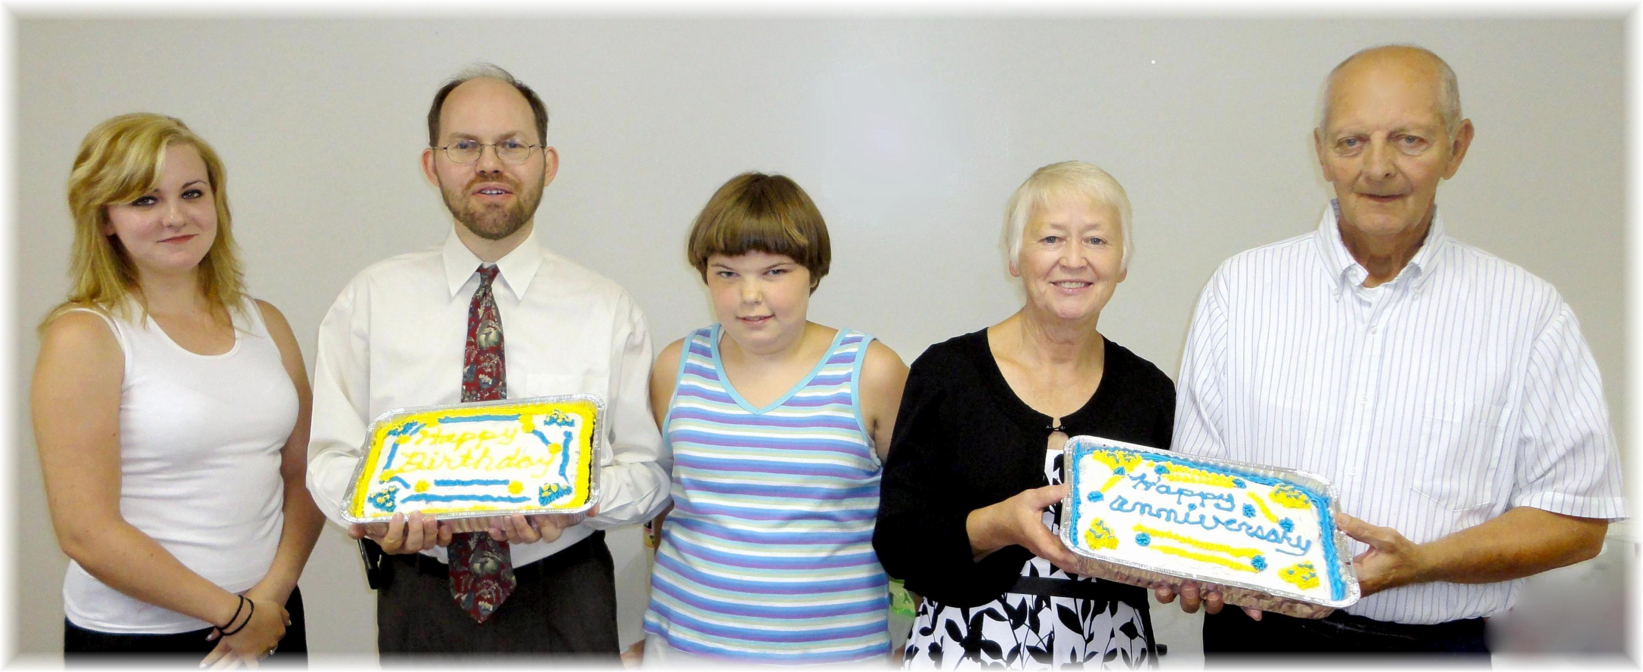
Birthdays: Shaina, James, Tiffany Anniversary: Sharon & Jim
July Birthdays and Anniversary – 2011

