Lancaster Seventh-Day Adventist Church
A House of Prayer for All People

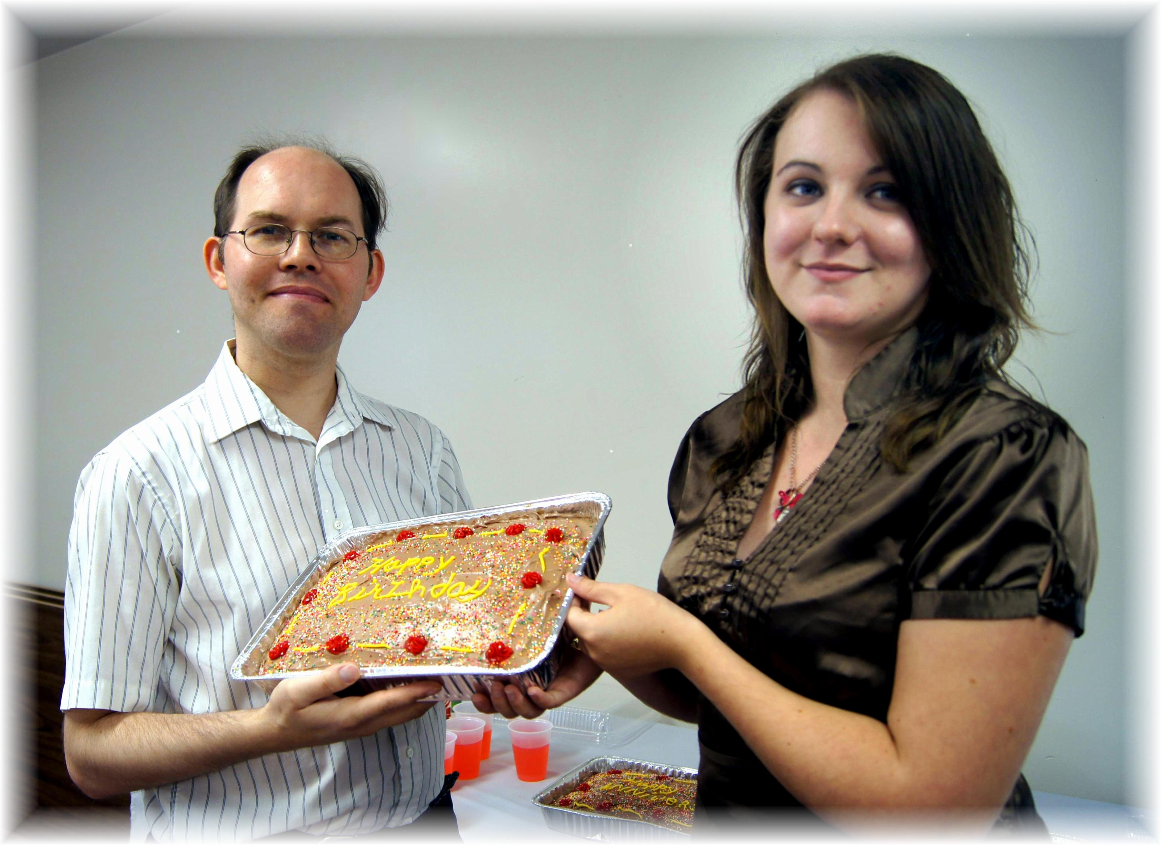
Birthdays: James, Shaina
July Birthdays – 2012

