Lancaster Seventh-Day Adventist Church
A House of Prayer for All People

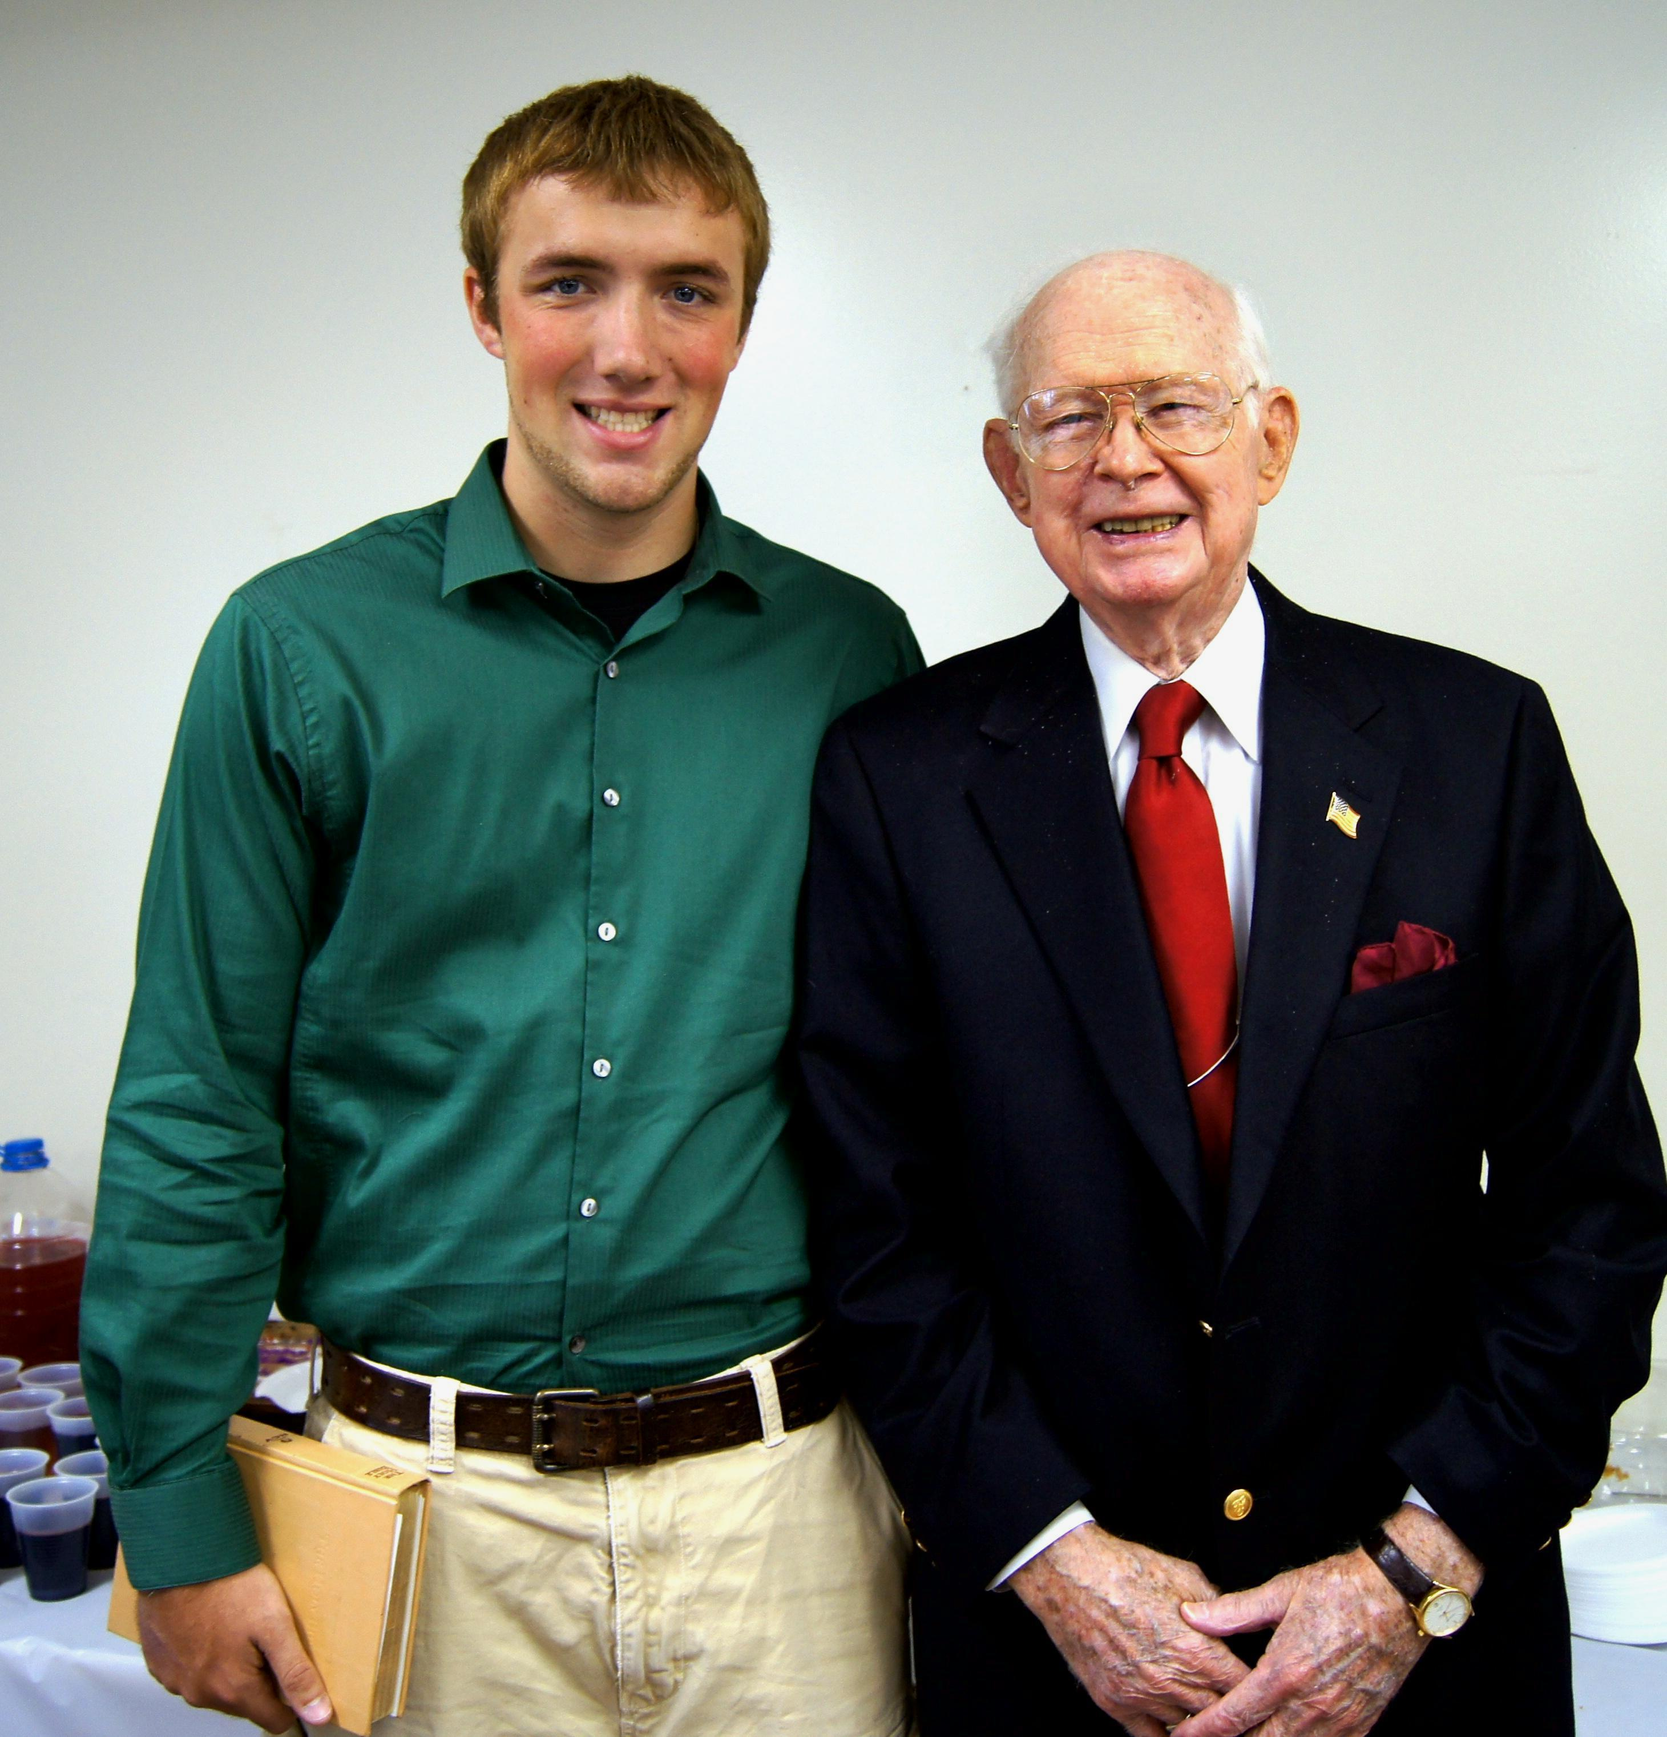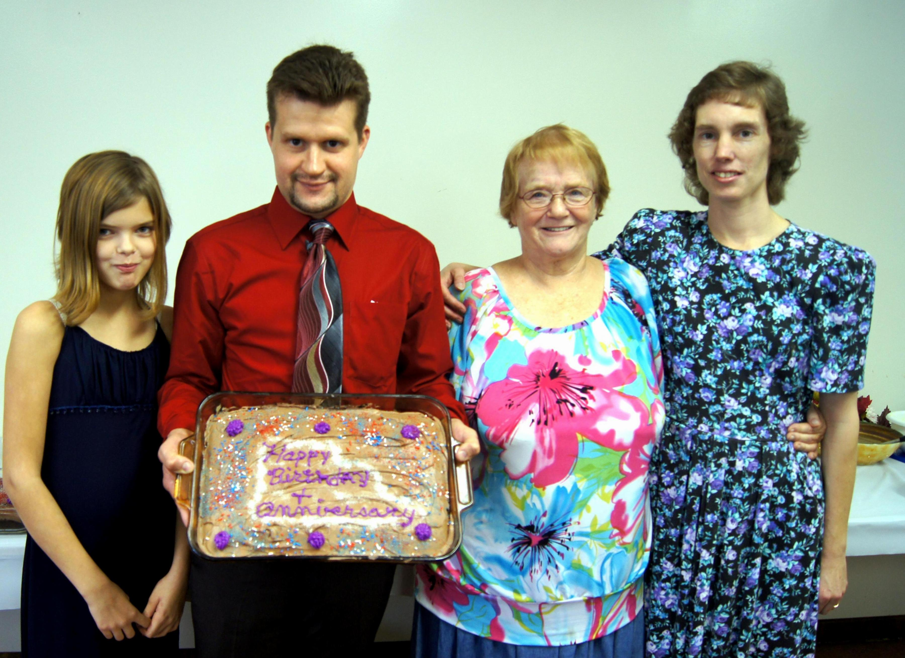
Nathan Mathias, Ralph Aldenderfer, Tabby Marcum, Allen Cramblit, Sandy Hoover, Connie Duncan
September Birthdays - 2012

