Lancaster Seventh-Day Adventist Church
A House of Prayer for All People

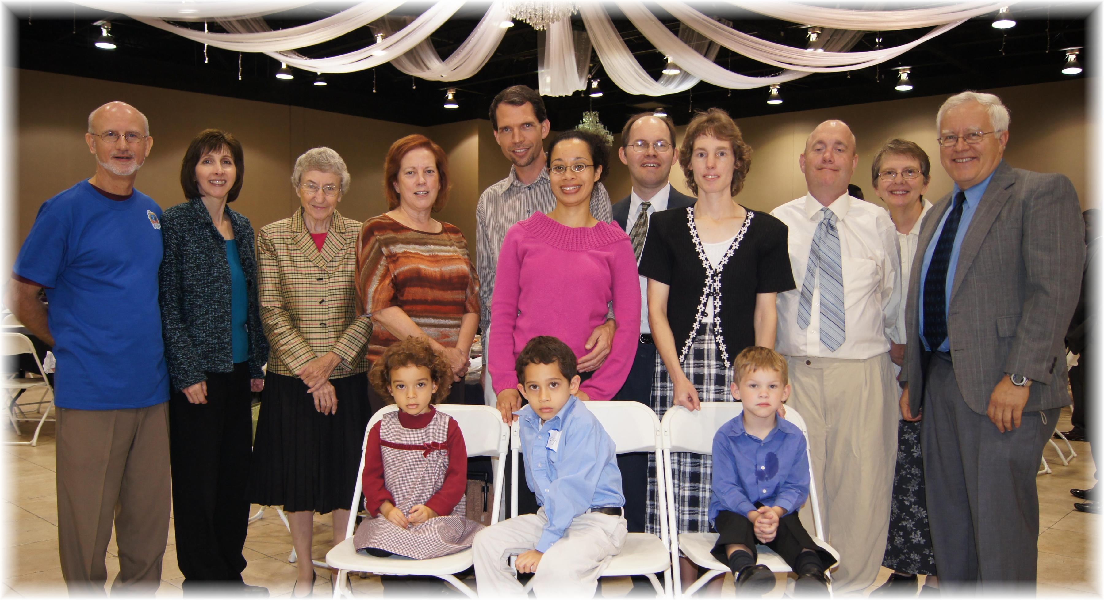

A New Song – Wilmington, OH - September 22, 2012

