Lancaster Seventh-Day Adventist Church
A House of Prayer for All People

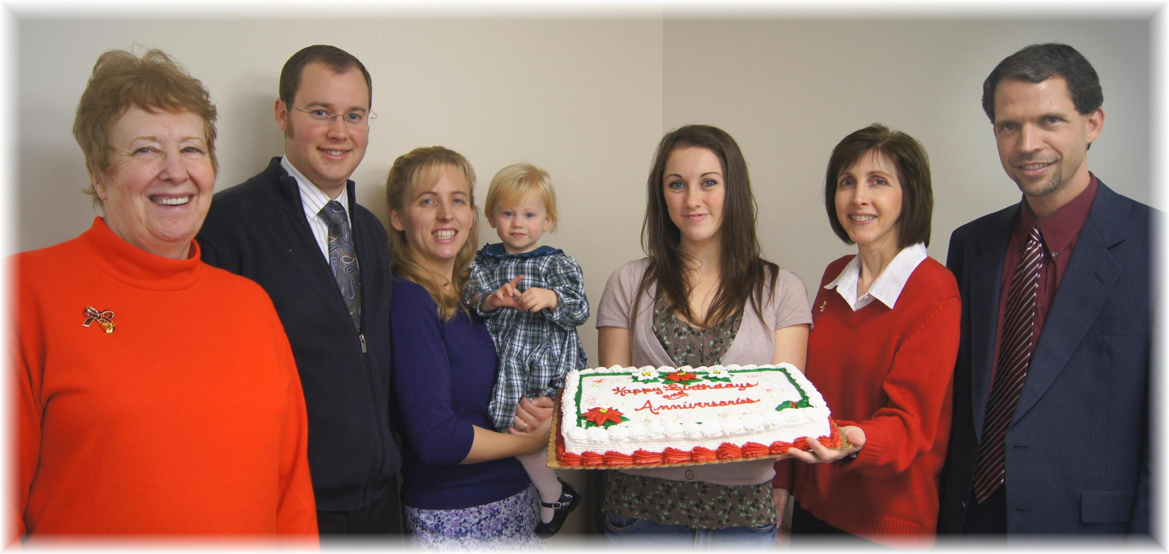
Anniversaries: Diane, Joel & Marijke Birthdays: Chloe, Corrie, Nancy, Travis
December Anniversaries and Birthdays - 2012

