Lancaster Seventh-Day Adventist Church
A House of Prayer for All People

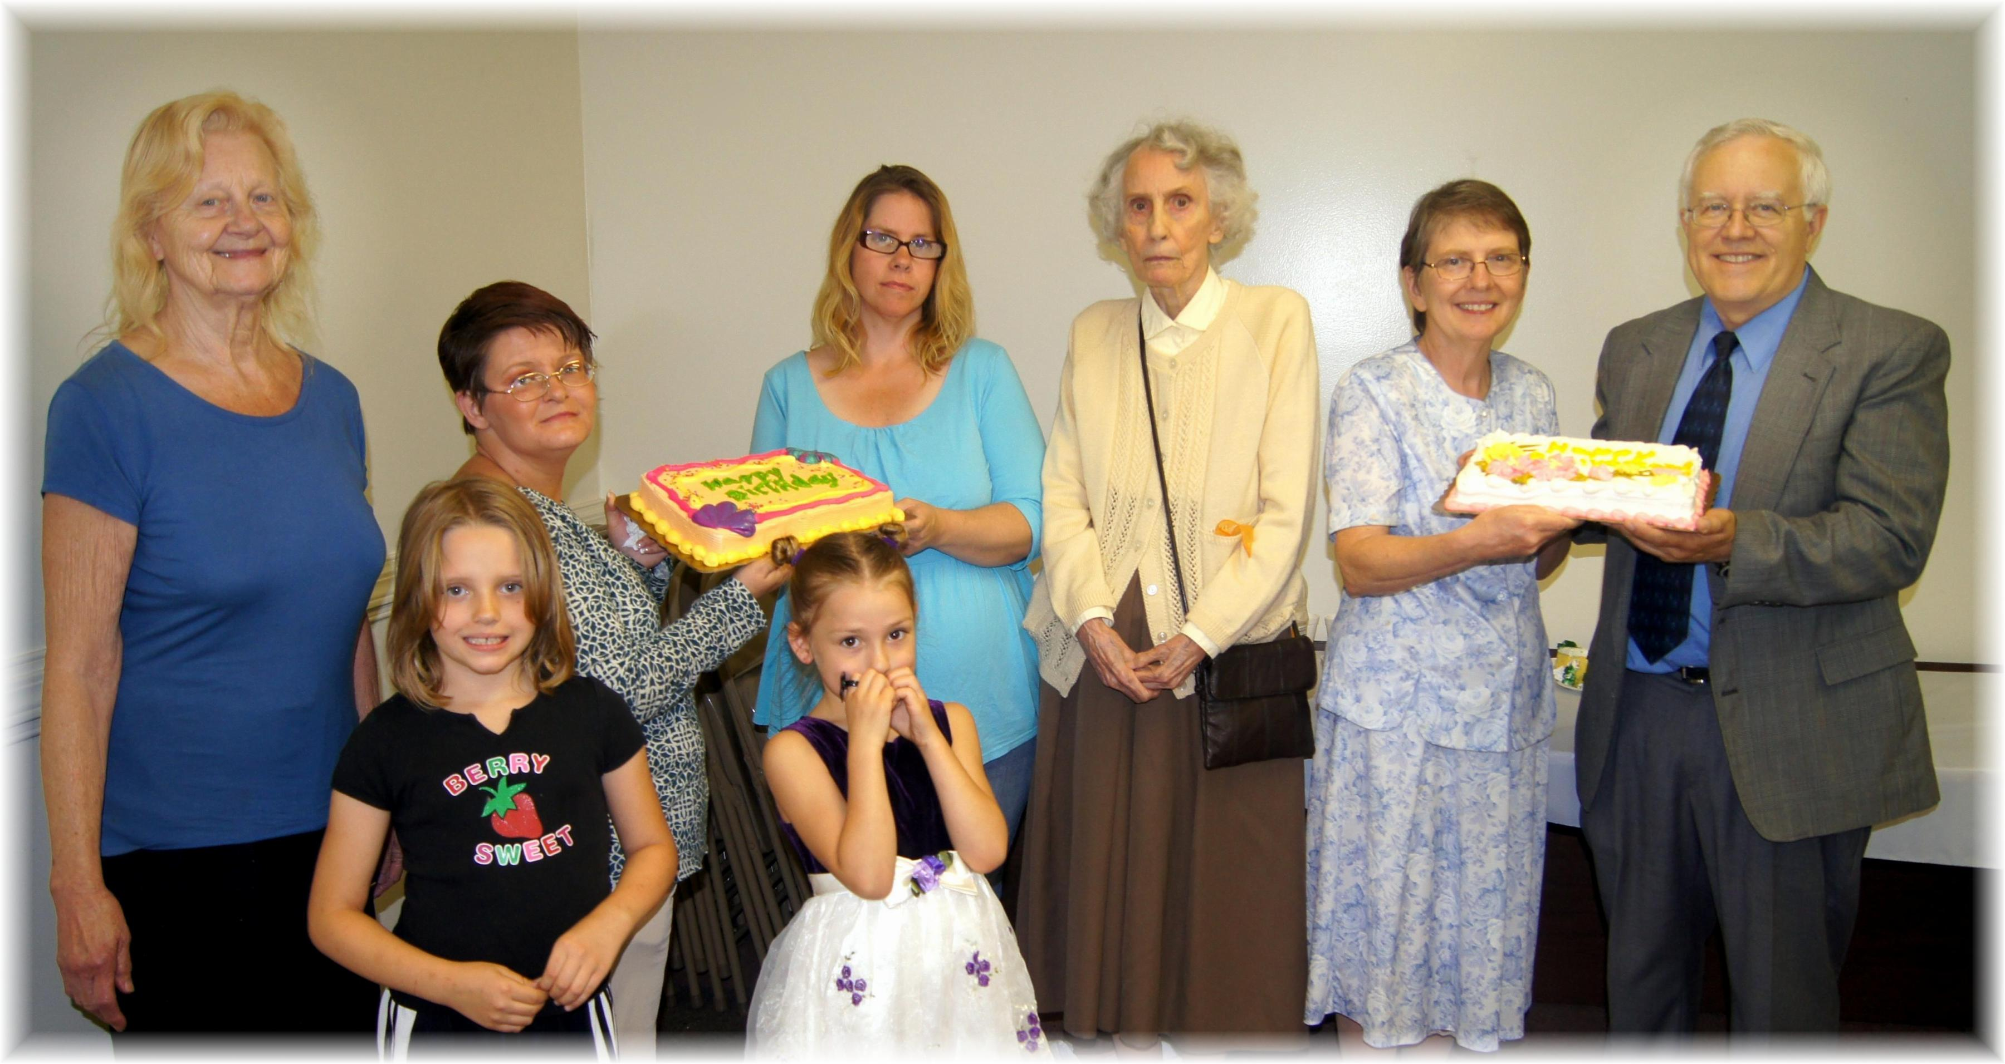
Birthdays: Pat, Sandra, Amy, Delana, Andrea, Edna . Anniversary: Bonnie & Al
Birthdays and Anniversary – June, 2013

