Lancaster Seventh-Day Adventist Church
A House of Prayer for All People
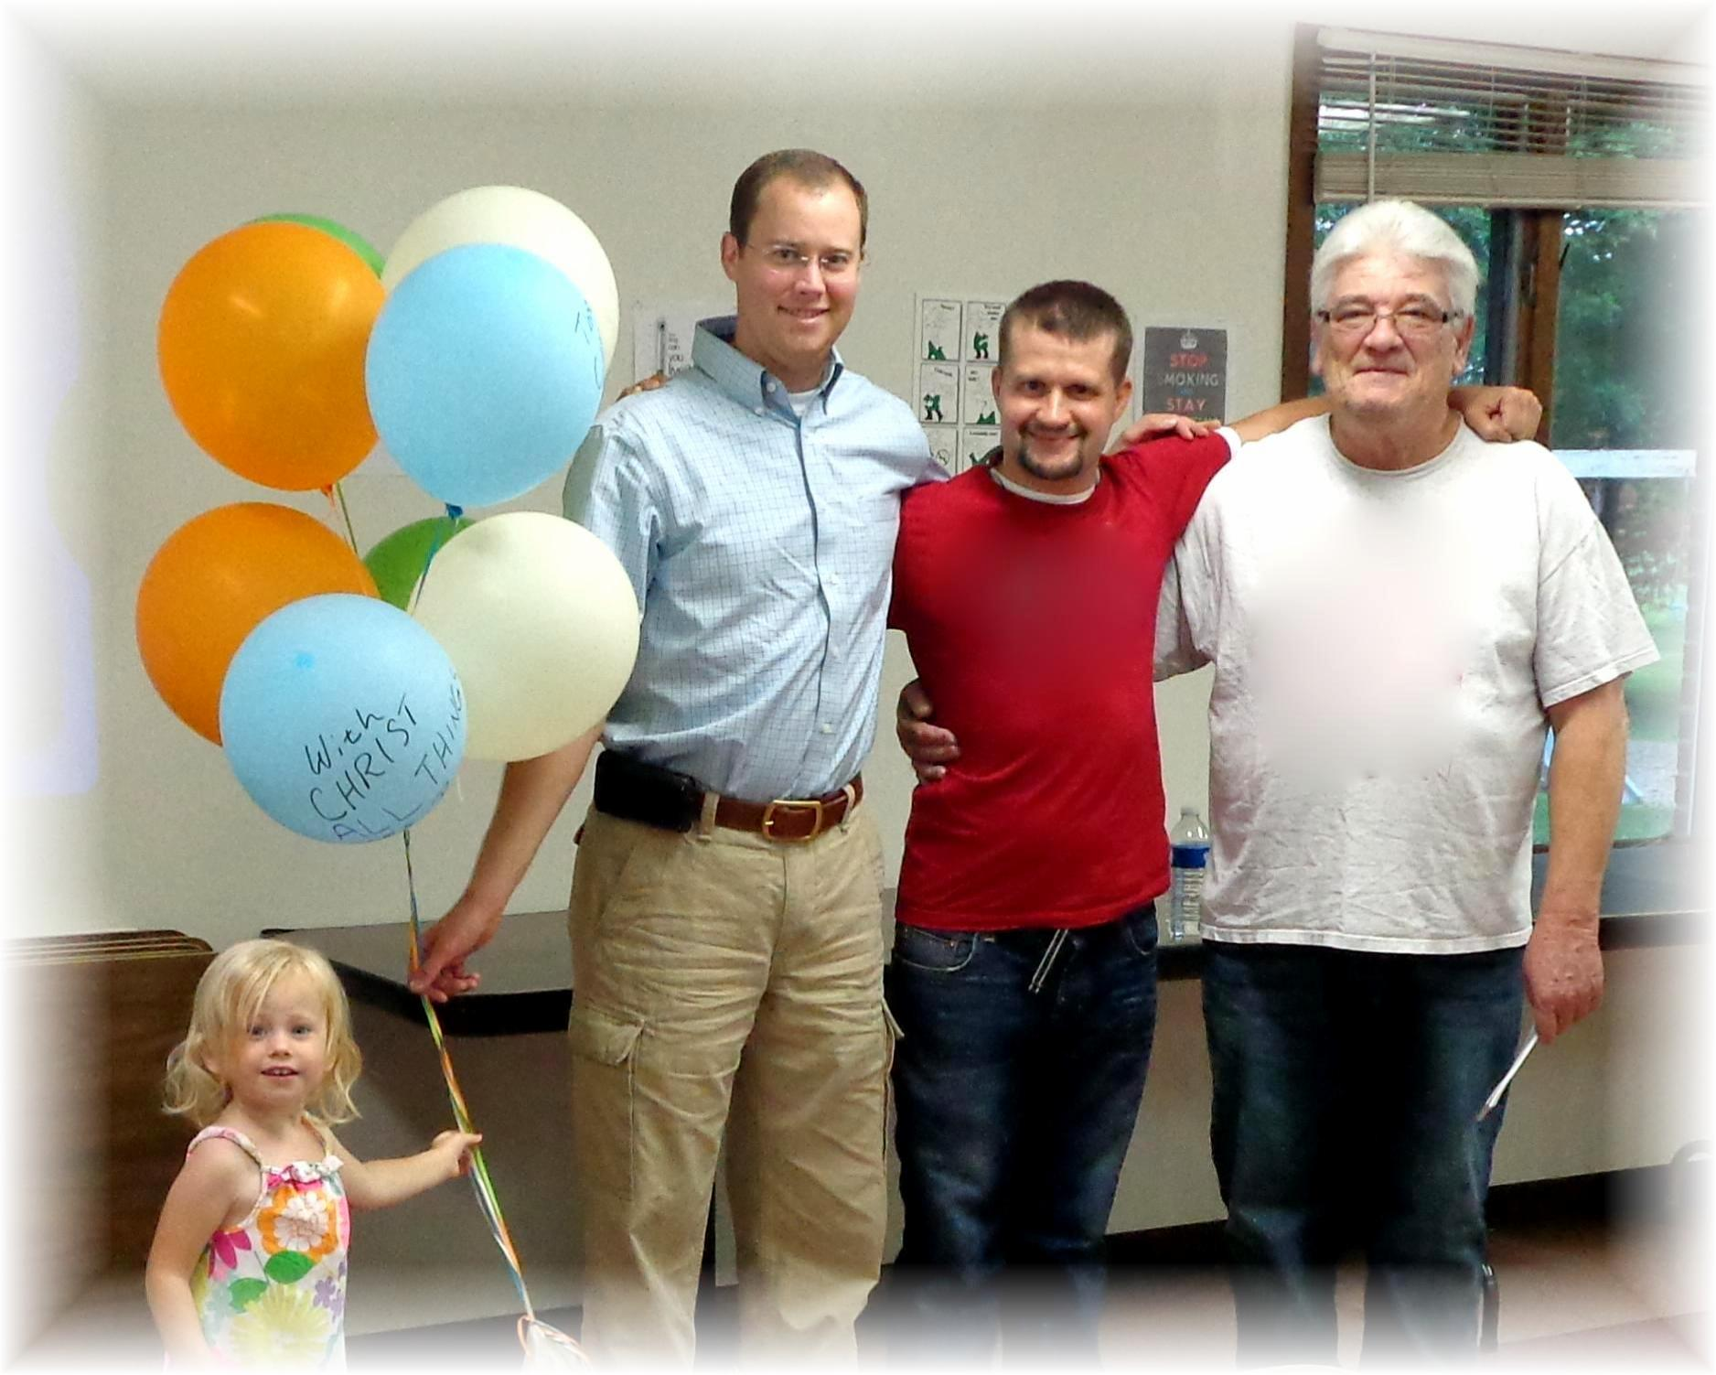
Chloe, Joel, Allen, John
Breath Free Classes Begin - July 1, 2013

