Lancaster Seventh-Day Adventist Church
A House of Prayer for All People

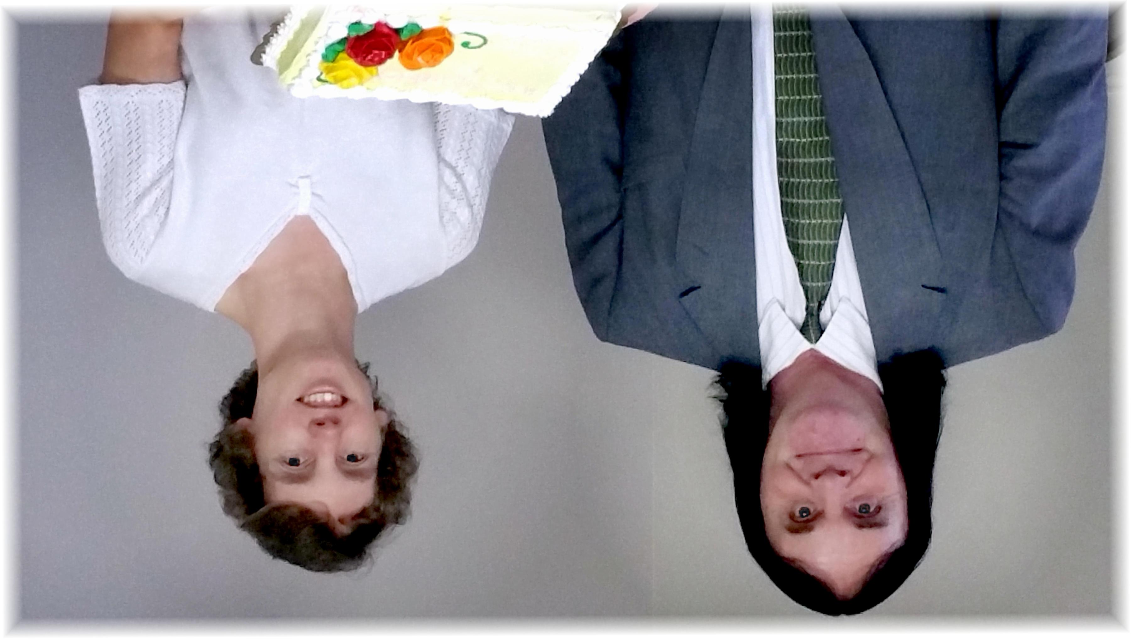
George and Connie
September Birthdays - 2015

